WP Lab 4 – JQuery

Q1 - Write a web page which contains table with 3 X 3 dimensions (fill some data) and one
image. Style the rows with alternate color. Move the table and image together from
right to left when button is clicked.

Code -

<!DOCTYPE html>
<html lang="en">
<head>
<meta charset="UTF-8">
<meta name="viewport" content="width=device-width, initial-scale=1.0">
<title>Table & Image Animation</title>
<script src="https://code.jquery.com/jquery-3.6.0.min.js"></script>
<style>
body {
font-family: Arial, sans-serif;
display: flex;
flex-direction: column;
justify-content: center;
align-items: center;
height: 100vh;
background: linear-gradient(to right, #f0f0f0, #d9e3f0);
overflow: hidden;
}
.playground {
width: 1000px;
height: 800px;
border: 2px solid #333;
position: relative;
overflow: hidden;
background-color: #fff;
display: flex;
justify-content: center;
align-items: center;
}
.content {
display: flex;
align-items: center;
position: absolute;
transition: transform 0.5s ease-in-out;
}
table {
width: 300px;
border-collapse: collapse;
margin-right: 20px;
}
th, td {
border: 1px solid #000;
padding: 10px;
text-align: center;
}
tr:nth-child(2) {
background-color: red !important;
color: white;
}
tr:nth-child(even) {
background-color: #f2f2f2;
}
tr:nth-child(odd) {
background-color: #e0e0e0;
}
.controls {
margin-top: 20px;
}
button {
padding: 10px 20px;
background: #4CAF50;
color: white;
border: none;
cursor: pointer;
font-size: 16px;
border-radius: 5px;
transition: background 0.3s;
}
button:hover {
background: #45a049;
}
</style>
</head>
<body>
<div class="playground">
<div class="content" id="moveContent">
<table>
<tr>
<th>Item</th>
<th>Price</th>
<th>Quantity</th>
</tr>
<tr>
<td>Phone</td>
<td>$500</td>
<td>2</td>
</tr>
<tr>
<td>Laptop</td>
<td>$1000</td>
<td>1</td>
</tr>
<tr>
<td>Tablet</td>
<td>$300</td>
<td>3</td>
</tr>
</table>
<img src="./q1.jpeg" alt="Sample Image">
</div>
</div>
<div class="controls">
<button id="moveLeft">Move Left</button>
</div>

<script>
$(document).ready(function() {
let x = 0;
const step = 200;

function updatePosition() {
$("#moveContent").css("transform", `translate(${x}px, 0px)`);
}

$("#moveLeft").click(function() {
x -= step;
updatePosition();
});
});
</script>
</body>
</html>

Output -

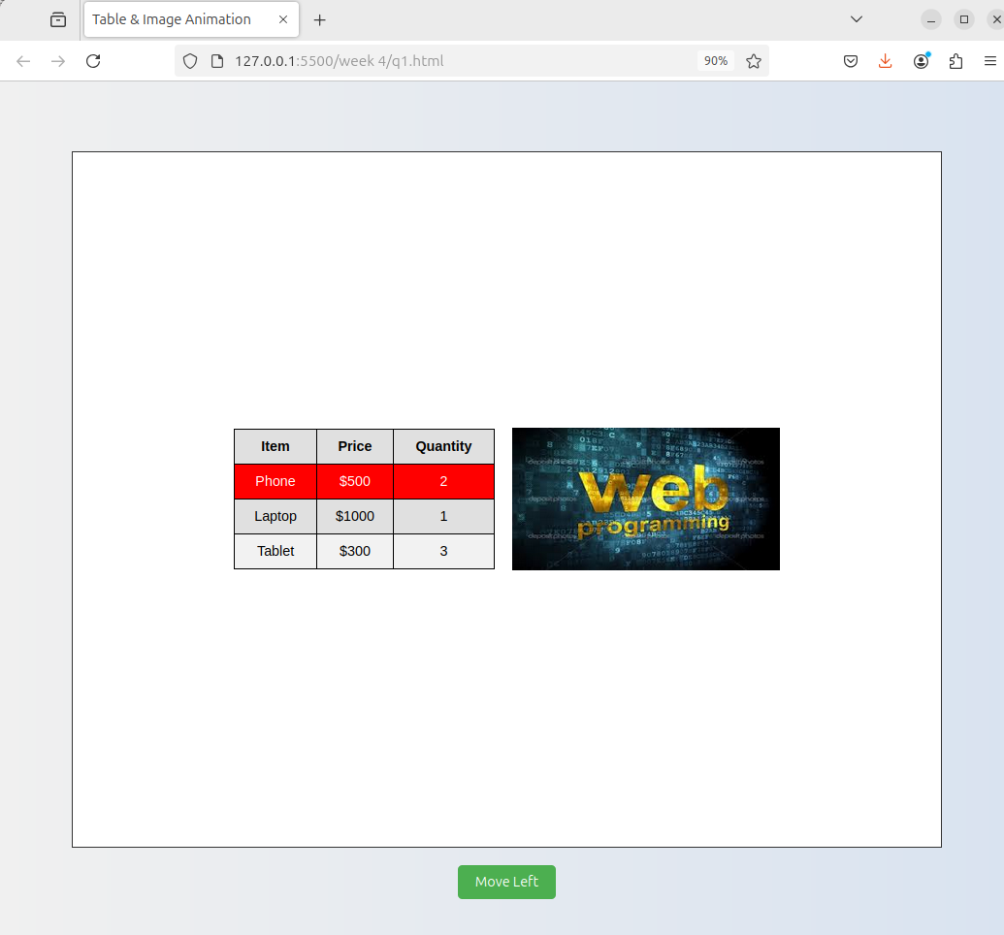
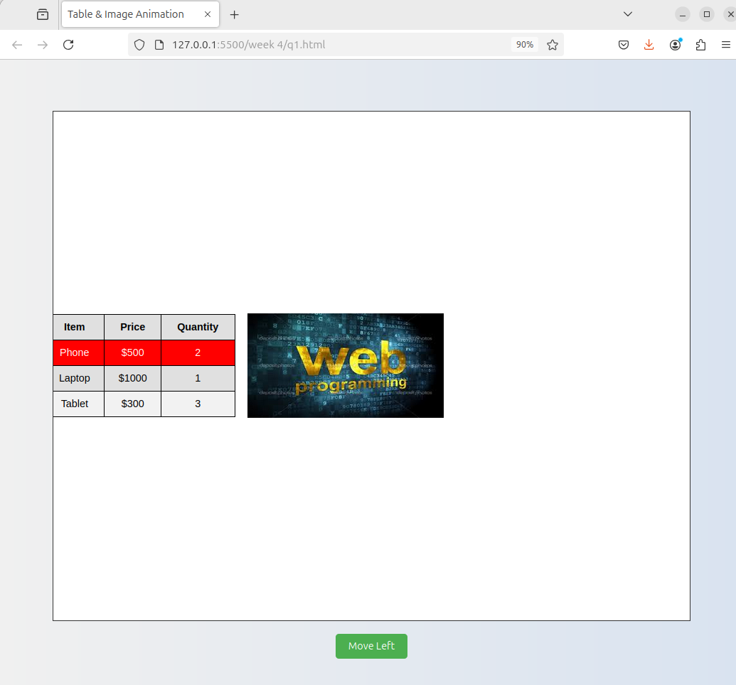

Q2 - Design a calculator to perform basic arithmetic operations. Use textboxes and buttons
to design web page.

Code -

<!DOCTYPE html>
<html lang="en">
<head>
<meta charset="UTF-8">
<meta name="viewport" content="width=device-width, initial-scale=1.0">
<title>Calculator</title>
<link href="https://cdn.jsdelivr.net/npm/bootstrap@5.3.0-alpha1/dist/css/bootstrap.min.css" rel="stylesheet">
<style>
body {
background-color: #f0f2f5;
display: flex;
justify-content: center;
align-items: center;
height: 100vh;
margin: 0;
font-family: 'Arial', sans-serif;
}
.calculator {
background-color: #ffffff;
border-radius: 20px;
box-shadow: 0 10px 30px rgba(0, 0, 0, 0.1);
padding: 30px;
width: 320px;
}
#display {
font-size: 2.5rem;
height: 70px;
margin-bottom: 20px;
text-align: right;
border: none;
background-color: #f8f9fa;
border-radius: 10px;
padding: 10px;
box-shadow: inset 0 2px 5px rgba(0, 0, 0, 0.1);
}
.btn-calculator {
font-size: 1.5rem;
height: 65px;
border-radius: 15px;
border: none;
transition: all 0.2s ease-in-out;
}
.btn-calculator:hover {
transform: translateY(-2px);
box-shadow: 0 4px 8px rgba(0, 0, 0, 0.1);
}
.btn-light {
background-color: #f8f9fa;
color: #495057;
}
.btn-operator {
background-color: #4dabf7;
color: white;
}
.btn-clear {
background-color: #ff6b6b;
color: white;
}
.btn-equals {
background-color: #51cf66;
color: white;
}
</style>
</head>
<body>
<div class="calculator">
<input type="text" id="display" class="form-control mb-4" readonly>
<div class="row g-2">
<div class="col-3"><button class="btn btn-clear btn-calculator w-100">C</button></div>
<div class="col-3"><button class="btn btn-light btn-calculator w-100">(</button></div>
<div class="col-3"><button class="btn btn-light btn-calculator w-100">)</button></div>
<div class="col-3"><button class="btn btn-operator btn-calculator w-100">/</button></div>
<div class="col-3"><button class="btn btn-light btn-calculator w-100">7</button></div>
<div class="col-3"><button class="btn btn-light btn-calculator w-100">8</button></div>
<div class="col-3"><button class="btn btn-light btn-calculator w-100">9</button></div>
<div class="col-3"><button class="btn btn-operator btn-calculator w-100">*</button></div>
<div class="col-3"><button class="btn btn-light btn-calculator w-100">4</button></div>
<div class="col-3"><button class="btn btn-light btn-calculator w-100">5</button></div>
<div class="col-3"><button class="btn btn-light btn-calculator w-100">6</button></div>
<div class="col-3"><button class="btn btn-operator btn-calculator w-100">-</button></div>
<div class="col-3"><button class="btn btn-light btn-calculator w-100">1</button></div>
<div class="col-3"><button class="btn btn-light btn-calculator w-100">2</button></div>
<div class="col-3"><button class="btn btn-light btn-calculator w-100">3</button></div>
<div class="col-3"><button class="btn btn-operator btn-calculator w-100">+</button></div>
<div class="col-6"><button class="btn btn-light btn-calculator w-100">0</button></div>
<div class="col-3"><button class="btn btn-light btn-calculator w-100">.</button></div>
<div class="col-3"><button class="btn btn-equals btn-calculator w-100">=</button></div>
</div>
</div>
<script src="https://code.jquery.com/jquery-3.6.0.min.js"></script>
<script src="https://cdn.jsdelivr.net/npm/bootstrap@5.3.0-alpha1/dist/js/bootstrap.bundle.min.js"></script>
<script>
$(document).ready(function() {
let display = $("#display");
let currentInput = "";

$(".btn-calculator").click(function() {
let buttonValue = $(this).text();
if (buttonValue === "C") {
currentInput = "";
} else if (buttonValue === "=") {
try {
currentInput = eval(currentInput).toString();
} catch (error) {
currentInput = "Error";
}
} else {
currentInput += buttonValue;
}
display.val(currentInput);
});
$(".btn-calculator").hover(
function() {
$(this).addClass("shadow-sm");
},
function() {
$(this).removeClass("shadow-sm");
}
);
});
</script>
</body>
</html>

Output -

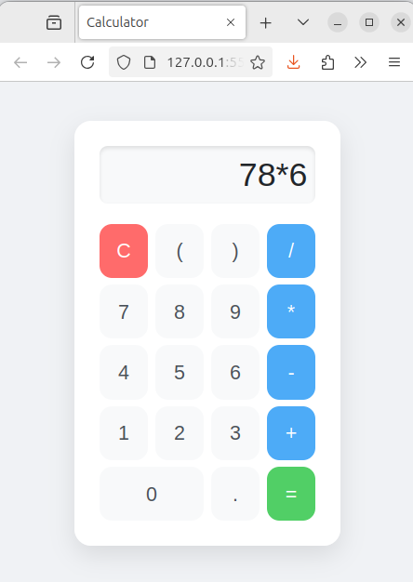

Q3 - Create a web page to design a birthday card shown below.

Code -

<!DOCTYPE html>
<html lang="en">
<head>
<meta charset="UTF-8">
<meta name="viewport" content="width=device-width, initial-scale=1.0">
<title>Birthday Card Designer</title>
<script src="https://code.jquery.com/jquery-3.6.0.min.js"></script>
<style>
body {
font-family: Arial, sans-serif;
display: flex;
justify-content: center;
align-items: center;
height: 100vh;
}
.container {
display: flex;
gap: 20px;
background: #fff;
padding: 20px;
border-radius: 10px;
box-shadow: 0px 0px 20px rgba(0, 0, 0, 0.2);
}
.controls {
background:#fdff6f;
padding: 20px;
border-radius: 10px;
box-shadow: 0px 0px 10px rgba(0, 0, 0, 0.1);
}
.card {
width: 300px;
height: 490px;
text-align: center;
padding: 20px;
border: 5px double black;
transition: all 0.3s ease-in-out;
}
.card:hover {
transform: scale(1.05);
}
.card img {
width: 150px;
margin-top: 20px;
border-radius: 10px;
box-shadow: 0px 0px 10px rgba(0, 0, 0, 0.2);
}
textarea, select, input {
width: 100%;
margin: 5px 0;
padding: 8px;
border-radius: 5px;
border: 1px solid #ccc;
}
.radio-group, .checkbox-group {
display: flex;
align-items: center;
gap: 10px;
}
button {
background: #ff4081;
color: white;
border: none;
padding: 10px;
width: 100%;
border-radius: 5px;
cursor: pointer;
font-size: 16px;
}
button:hover {
background: #d81b60;
}
</style>
</head>
<body>
<div class="container">
<div class="controls">
<label>Choose a background color:</label>
<select id="bgColor">
<option value="yellow">Yellow</option>
<option value="pink">Pink</option>
<option value="lightblue">Light Blue</option>
</select>
<br>
<label>Choose a font:</label>
<select id="font">
<option value="Verdana">Verdana</option>
<option value="Arial">Arial</option>
<option value="Times New Roman">Times New Roman</option>
</select>
<br>
<label>Specify a numeric font size:</label>
<input type="number" id="fontSize" value="25">
<br>
<label>Choose a border style:</label>
<div class="radio-group">
<input type="radio" name="border" value="none"> None
<input type="radio" name="border" value="double" checked> Double
<input type="radio" name="border" value="solid"> Solid
</div>
<br>
<div class="checkbox-group">
<input type="checkbox" id="defaultImage" checked> <label for="defaultImage">Add the Default Picture</label>
</div>
<br>
<label>Enter the greeting text below:</label>
<textarea id="greeting">Happy Birthday, and many more</textarea>
<br>
<button id="update">Update</button>
</div>
<div class="card" id="card">
<h2 id="message">Happy Birthday, and many more</h2>
<img id="cardImage" src="./q3.jpg" alt="Birthday Cake">
</div>
</div>

<script>
$(document).ready(function() {
$("#update").click(function() {
$("#card").css("background-color", $("#bgColor").val());
$("#message").css({
"font-family": $("#font").val(),
"font-size": $("#fontSize").val() + "px"
});
$("#message").text($("#greeting").val());
let borderStyle = $("input[name='border']:checked").val();
$("#card").css("border", borderStyle === "none" ? "none" : "5px " + borderStyle + " black");
if($("#defaultImage").is(":checked")) {
$("#cardImage").show();
} else {
$("#cardImage").hide();
}
});
});
</script>
</body>
</html>

Output -

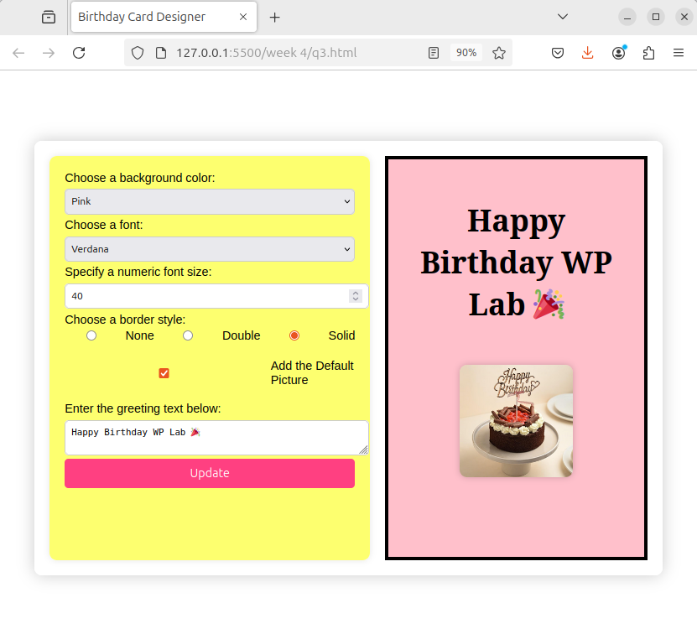

Q4 - Design a webpage. The page contains:
• Dropdown list with HP, Nokia, Samsung, Motorola, Apple as items.
• Checkbox with Mobile and Laptop as items. Textbox where you enter quantity.
• There is a button with text as ‘Produce Bill’.
On Clicking Produce Bill button, alert should be displayed with total amount.

Code -

<!DOCTYPE html>
<html lang="en">
<head>
<meta charset="UTF-8">
<meta name="viewport" content="width=device-width, initial-scale=1.0">
<title>Tech Store Billing</title>
<link href="https://cdn.jsdelivr.net/npm/bootstrap@5.3.0-alpha1/dist/css/bootstrap.min.css" rel="stylesheet">
<link href="https://cdnjs.cloudflare.com/ajax/libs/font-awesome/6.0.0-beta3/css/all.min.css" rel="stylesheet">
<style>
body {
background-color: #f0f2f5;
padding-top: 50px;
}
.card {
border: none;
border-radius: 20px;
box-shadow: 0 10px 30px rgba(0, 0, 0, 0.1);
overflow: hidden;
}
.card-header {
background-color: #4a90e2;
color: white;
padding: 20px;
border-bottom: none;
}
.card-title {
font-size: 24px;
font-weight: 600;
margin-bottom: 0;
}
.card-body {
padding: 30px;
}
.form-label {
font-weight: 500;
color: #333;
margin-bottom: 8px;
}
.form-select, .form-control {
border-radius: 10px;
border: 1px solid #ced4da;
padding: 12px;
}
.form-select:focus, .form-control:focus {
border-color: #4a90e2;
box-shadow: 0 0 0 0.2rem rgba(74, 144, 226, 0.25);
}
.product-type {
display: flex;
justify-content: space-around;
margin-bottom: 20px;
}
.product-option {
text-align: center;
}
.product-icon {
font-size: 24px;
color: #4a90e2;
margin-bottom: 10px;
}
.btn-primary {
background-color: #4a90e2;
border: none;
border-radius: 10px;
padding: 12px 24px;
font-weight: 600;
}
.btn-primary:hover {
background-color: #3a7bc8;
}
</style>
</head>
<body>
<div class="container">
<div class="row justify-content-center">
<div class="col-md-6">
<div class="card">
<div class="card-header">
<h3 class="card-title">Tech Store Billing</h3>
</div>
<div class="card-body">
<form id="billingForm">
<div class="mb-4">
<label for="brand" class="form-label">Select Brand</label>
<select id="brand" class="form-select">
<option value="">Choose a brand</option>
<option value="HP">HP</option>
<option value="Nokia">Nokia</option>
<option value="Samsung">Samsung</option>
<option value="Motorola">Motorola</option>
<option value="Apple">Apple</option>
</select>
</div>
<div class="mb-4">
<label class="form-label">Product Type</label>
<div class="product-type">
<div class="product-option">
<i class="fas fa-mobile-alt product-icon"></i>
<div class="form-check">
<input class="form-check-input" type="checkbox" value="Mobile" id="mobileCB">
<label class="form-check-label" for="mobileCB">
Mobile
</label>
</div>
</div>
<div class="product-option">
<i class="fas fa-laptop product-icon"></i>
<div class="form-check">
<input class="form-check-input" type="checkbox" value="Laptop" id="laptopCB">
<label class="form-check-label" for="laptopCB">
Laptop
</label>
</div>
</div>
</div>
</div>
<div class="mb-4">
<label for="quantity" class="form-label">Quantity</label>
<input type="number" class="form-control" id="quantity" min="1" value="1">
</div>
<div class="text-center">
<button type="button" id="produceBill" class="btn btn-primary">
<i class="fas fa-file-invoice-dollar me-2"></i>Produce Bill
</button>
</div>
</form>
</div>
</div>
</div>
</div>
</div>

<script src="https://code.jquery.com/jquery-3.6.0.min.js"></script>
<script src="https://cdn.jsdelivr.net/npm/bootstrap@5.3.0-alpha1/dist/js/bootstrap.bundle.min.js"></script>
<script>
$(document).ready(function() {
const prices = {
HP: { Mobile: 300, Laptop: 800 },
Nokia: { Mobile: 250, Laptop: 700 },
Samsung: { Mobile: 400, Laptop: 900 },
Motorola: { Mobile: 350, Laptop: 750 },
Apple: { Mobile: 800, Laptop: 1500 }
};

$("#produceBill").click(function() {
const brand = $("#brand").val();
const quantity = parseInt($("#quantity").val());
let total = 0;
let products = [];

if (!brand) {
alert("Please select a brand.");
return;
}

if ($("#mobileCB").is(":checked")) {
total += prices[brand].Mobile * quantity;
products.push(`Mobile x${quantity}`);
}

if ($("#laptopCB").is(":checked")) {
total += prices[brand].Laptop * quantity;
products.push(`Laptop x${quantity}`);
}

if (total === 0) {
alert("Please select at least one product type.");
} else {
alert(`Bill Details:\n\nBrand: ${brand}\nProducts: ${products.join(', ')}\nTotal Amount: $${total.toFixed(2)}`);
}
});
});
</script>
</body>
</html>

Output -
